System Design Document

# Hardware:

## Actuators:

* Embedded board (STM Nucleo 64) – Arm Cortex M3/M4
* ETRX357 Zigbee module (UART, AT-Commands)

## Sensors:

* Cubic CM1106 CO2 sensor (UART)
* Sensirion SHT20x humidity/temperature sensor (I2C)
* Sensirion SPS30 Particulate Matter sensor (I2C/UART)

## Wiring diagrams:

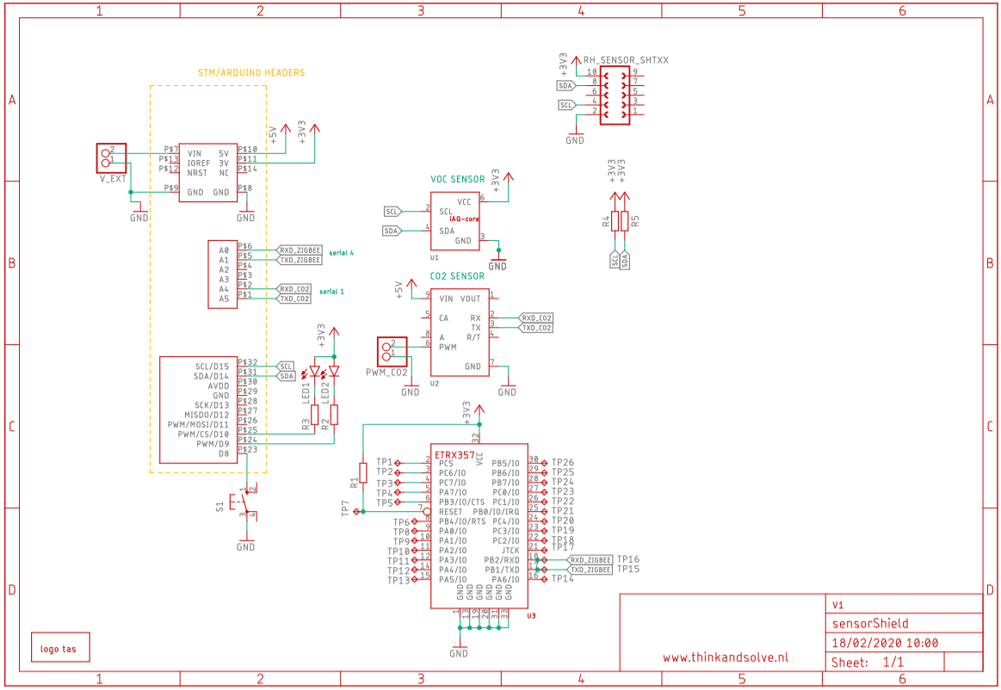

# System design

## System architecture diagram

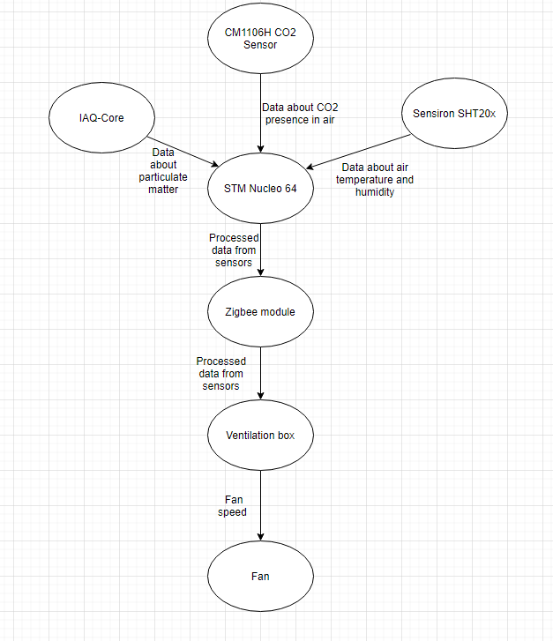

## System context diagram

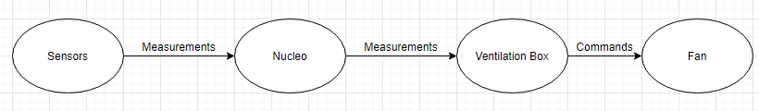

# Communication protocols

Messages are sent every 15 minutes and at sharp changes of CO2, matter, temperature or humidity.

STM Nucleo – master;

ZigBee Module – slave;

# State diagram

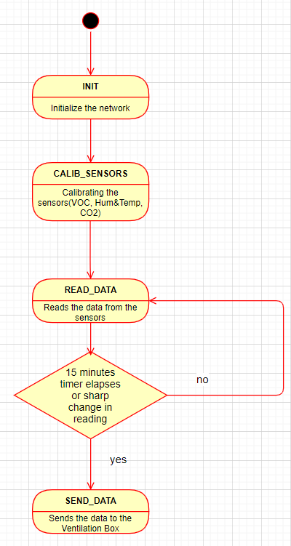

# Control flow chart

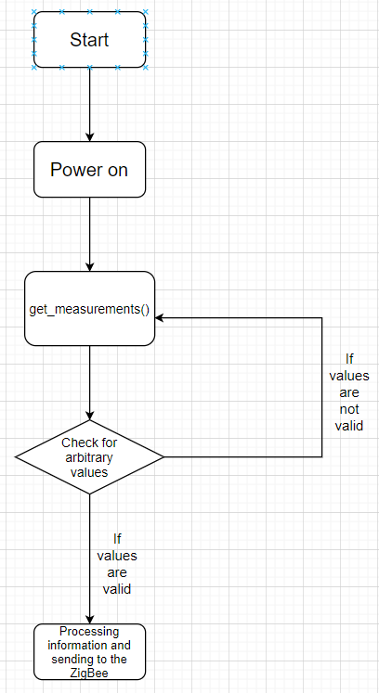

* The flow chart for the communication between the modules and the ZigBee.
* The flow chart for the communication between the ZigBee and the Ventilation Box.

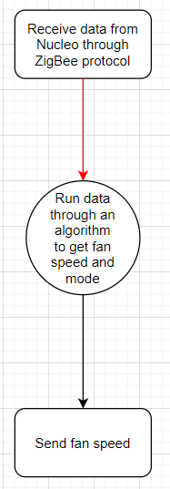

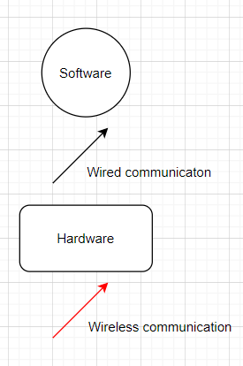

* The flow chart for the communication between the Ventilation Box and the fan.

